**Saroni Global Business Pvt. Ltd.**

Head office: 2nd Floor, Ganesh Market, LIC Buiding, Near UCO Bank, Narengi Tiniali, Guwahati, Assam, India, PIN: 781026

Mob: +91-7002329489 / 9859931042

Email: [trade@saroniglobal.com](mailto:trade@saroniglobal.com)

# Non Pesticides 1121 Steam Rice on European Norms

**Specifications**

| Purity | – 95.00% |
| --- | --- |
| Natural Admixture | – 5.00% |
| Average Grain Length | – 7.30 MM |
| Moisture | – 12.5% Max. |
| Broken Grain | – 1% Max. |
| Damage/Discolour Grain | – 1% Max. |
| Immature Grain | – 1% Max. |
| Foreign Matter | – Nil |
| Packaging Type | – Jute bag, PP bag, Non-woven bag or as per buyer’s choice. |
| Supply Ability | – 2000 tons Per Week |
| Main Export Market(S) | – Europe, USA, Australia, Saudi Arabia, Kuwait, Egypt, UAE, Jordan, Oman, Bahrain, Yemen, Syria, Iraq, UAE, Libya, Turkey |
| Delivery Time | – 15 Days |

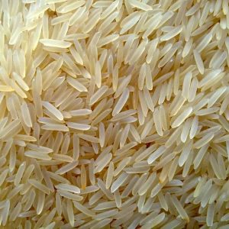  
**

# riNon Pesticides 1509 Steam Rice on European Norms

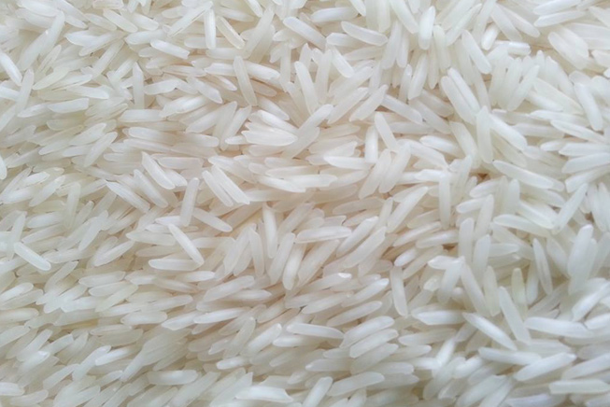**Specifications**

| Purity | – 95.00% |
| --- | --- |
| Natural Admixture | – 5.00% |
| Average Grain Length | – 7.30 MM |
| Moisture | – 12.5% Max. |
| Broken Grain | – 1% Max. |
| Damage/Discolour Grain | – 1% Max. |
| Immature Grain | – 1% Max. |
| Foreign Matter | – Nil |
| Packaging Type | – Jute bag, PP bag, Non-woven bag or as per buyer’s choice. |
| Supply Ability | – 2000 tons Per Week |
| Main Export Market(S) | – Europe, USA, Australia, Saudi Arabia, Kuwait, Egypt, UAE, Jordan, Oman, Bahrain, Yemen, Syria, Iraq, UAE, Libya, Turkey |
| Delivery Time | – 15 Days |

# Non Pesticides Sharbati Steam Rice on European Norms

## Specifications

| Purity | – 95.00% |
| --- | --- |
| Natural Admixture | – 5.00% |
| Average Grain Length | – 7.30 MM |
| Moisture | – 12.5% Max. |
| Broken Grain | – 1% Max. |
| Damage/Discolour Grain | – 1% Max. |
| Immature Grain | – 1% Max. |
| Foreign Matter | – Nil |
| Packaging Type | – Jute bag, PP bag, Non-woven bag or as per buyer’s choice. |
| Supply Ability | – 2000 tons Per Week |
| Main Export Market(S) | – Europe, USA, Australia, Saudi Arabia, Kuwait, Egypt, UAE, Jordan, Oman, Bahrain, Yemen, Syria, Iraq, UAE, Libya, Turkey |
| Delivery Time | – 15 Days |

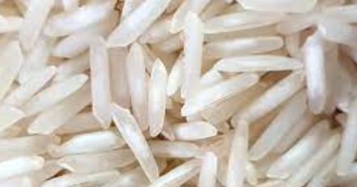  
**ars Of

# Non Pesticides Sharbati Sella Rice on European Norms

## https://www.sirra.co.in/wp-content/uploads/2022/04/1121-steam-basmati-rice-01-1.jpgSpecifications

| Purity | – 95.00% |
| --- | --- |
| Natural Admixture | – 5.00% |
| Average Grain Length | – 7.30 MM |
| Moisture | – 12.5% Max. |
| Broken Grain | – 1% Max. |
| Damage/Discolour Grain | – 1% Max. |
| Immature Grain | – 1% Max. |
| Foreign Matter | – Nil |
| Packaging Type | – Jute bag, PP bag, Non-woven bag or as per buyer’s choice. |
| Supply Ability | – 2000 tons Per Week |
| Main Export Market(S) | – Europe, USA, Australia, Saudi Arabia, Kuwait, Egypt, UAE, Jordan, Oman, Bahrain, Yemen, Syria, Iraq, UAE, Libya, Turkey |
| Delivery Time | – 15 Days |

5

Non Pesticides Sugandha Sella Rice on European Norms

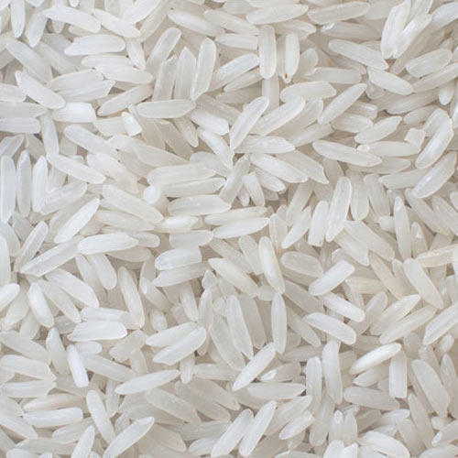**Specifications**

| Purity | – 95.00% |
| --- | --- |
| Natural Admixture | – 5.00% |
| Average Grain Length | – 7.30 MM |
| Moisture | – 12.5% Max. |
| Broken Grain | – 1% Max. |
| Damage/Discolour Grain | – 1% Max. |
| Immature Grain | – 1% Max. |
| Foreign Matter | – Nil |
| Packaging Type | – Jute bag, PP bag, Non-woven bag or as per buyer’s choice. |
| Supply Ability | – 2000 tons Per Week |
| Main Export Market(S) | – Europe, USA, Australia, Saudi Arabia, Kuwait, Egypt, UAE, Jordan, Oman, Bahrain, Yemen, Syria, Iraq, UAE, Libya, Turkey |
| Delivery Time | – 15 Days |

# Non Pesticides 1509 Sella Rice on European Norms

# Specifications

| Purity | – 95.00% |
| --- | --- |
| Natural Admixture | – 5.00% |
| Average Grain Length | – 7.30 MM |
| Moisture | – 12.5% Max. |
| Broken Grain | – 1% Max. |
| Damage/Discolour Grain | – 1% Max. |
| Immature Grain | – 1% Max. |
| Foreign Matter | – Nil |
| Packaging Type | – Jute bag, PP bag, Non-woven bag or as per buyer’s choice. |
| Supply Ability | – 2000 tons Per Week |
| Main Export Market(S) | – Europe, USA, Australia, Saudi Arabia, Kuwait, Egypt, UAE, Jordan, Oman, Bahrain, Yemen, Syria, Iraq, UAE, Libya, Turkey |
| Delivery Time | – 15 Days |

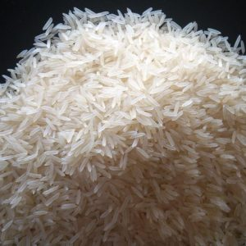  
Non Pesticides 1121 Sella Rice on European Norms

**Specifications**

| Purity | – 95.00% |
| --- | --- |
| Natural Admixture | – 5.00% |
| Average Grain Length | – 7.30 MM |
| Moisture | – 12.5% Max. |
| Broken Grain | – 1% Max. |
| Damage/Discolour Grain | – 1% Max. |
| Immature Grain | – 1% Max. |
| Foreign Matter | – Nil |
| Packaging Type | – Jute bag, PP bag, Non-woven bag or as per buyer’s choice. |
| Supply Ability | – 2000 tons Per Week |
| Main Export Market(S) | – Europe, USA, Australia, Saudi Arabia, Kuwait, Egypt, UAE, Jordan, Oman, Bahrain, Yemen, Syria, Iraq, UAE, Libya, Turkey |
| Delivery Time | – 15 Days |

## A picture containing text, vector graphics, clipart Description automatically generatedhttps://www.sirra.co.in/wp-content/uploads/2022/04/traditionalbasmatiriceparboiledrawjpg_1599375521-1.jpg Non Pesticides Sugandha Golden Sella Rice on European Norms

**Specifications**

| Purity | – 95.00% |
| --- | --- |
| Natural Admixture | – 5.00% |
| Average Grain Length | – 7.30 MM |
| Moisture | – 12.5% Max. |
| Broken Grain | – 1% Max. |
| Damage/Discolour Grain | – 1% Max. |
| Immature Grain | – 1% Max. |
| Foreign Matter | – Nil |
| Packaging Type | – Jute bag, PP bag, Non-woven bag or as per buyer’s choice. |
| Supply Ability | – 2000 tons Per Week |
| Main Export Market(S) | – Europe, USA, Australia, Saudi Arabia, Kuwait, Egypt, UAE, Jordan, Oman, Bahrain, Yemen, Syria, Iraq, UAE, Libya, Turkey |
| Delivery Time | – 15 Days |

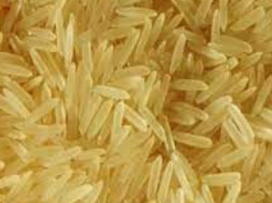  
Non Pesticides 1509 Golden Sella Rice on European Norms

**Specifications**

| Purity | – 95.00% |
| --- | --- |
| Natural Admixture | – 5.00% |
| Average Grain Length | – 7.30 MM |
| Moisture | – 12.5% Max. |
| Broken Grain | – 1% Max. |
| Damage/Discolour Grain | – 1% Max. |
| Immature Grain | – 1% Max. |
| Foreign Matter | – Nil |
| Packaging Type | – Jute bag, PP bag, Non-woven bag or as per buyer’s choice. |
| Supply Ability | – 2000 tons Per Week |
| Main Export Market(S) | – Europe, USA, Australia, Saudi Arabia, Kuwait, Egypt, UAE, Jordan, Oman, Bahrain, Yemen, Syria, Iraq, UAE, Libya, Turkey |
| Delivery Time | – 15 Days |

# A picture containing text, vector graphics, clipart Description automatically generatedhttps://www.sirra.co.in/wp-content/uploads/2022/04/pr11-golden-sella-non-basmati-rice-500x500-1.jpg Non Pesticides 1121 Golden Sella Rice on European Norms

# Specifications

| Purity | – 95.00% |
| --- | --- |
| Natural Admixture | – 5.00% |
| Average Grain Length | – 7.30 MM |
| Moisture | – 12.5% Max. |
| Broken Grain | – 1% Max. |
| Damage/Discolour Grain | – 1% Max. |
| Immature Grain | – 1% Max. |
| Foreign Matter | – Nil |
| Packaging Type | – Jute bag, PP bag, Non-woven bag or as per buyer’s choice. |
| Supply Ability | – 2000 tons Per Week |
| Main Export Market(S) | – Europe, USA, Australia, Saudi Arabia, Kuwait, Egypt, UAE, Jordan, Oman, Bahrain, Yemen, Syria, Iraq, UAE, Libya, Turkey |
| Delivery Time | – 15 Days |

